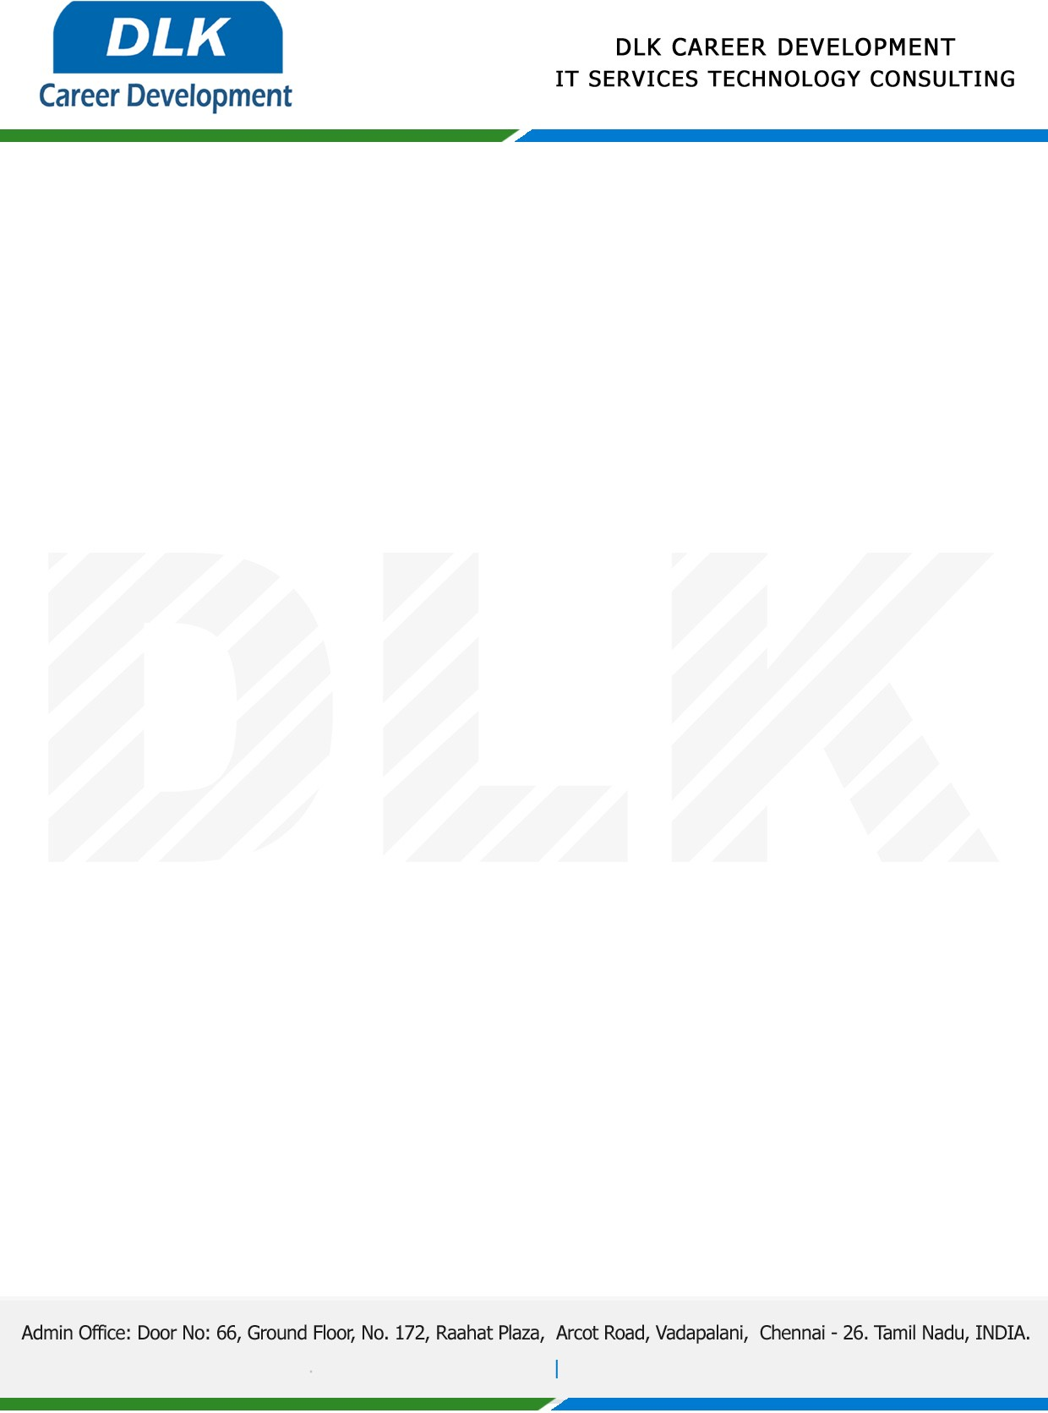

**Date: 18/April / 2023**

**SUB: INTERNSHIP COMPLETION CERTIFICATE**

This is to certify that **MS PAVITHRA K (REG NO:** **RA2152007010012)** of **MBA-Business Analytics** student at **College of Management SRM IST, Chennai** has Successfully Completed the Internship under the domain of **“Data Analytics “** in our organization during the Period **1st March 2023 to 18th April 2023**

We appreciate your interest in **DLK CAREER DEVELOPMENT**

**“Best Wishes for Your Future Endeavors “**

